I. Material Composition
Titan A16 is a multi-phase deterministic metal alloy requiring high purity (≥ 99.95%) for lattice stability.

Component Material Mass % Functional Role
Primary Anchor Tantalum (Ta) Primary Core mass, resonance anchor
Scaffold Titanium (Ti) Secondary Structural backbone, HCP lattice
Gasket Gold (Au) Interfacial Harmonic conductivity, passivation
Boundary Pinning Carbon (C) Trace Grain stabilization, fracture arrest
Grain Size Target: ≈ 1.618 µm.
Impurity Tolerance: < 0.001%.
II. Structural Architecture & Layer Specifications
The architecture utilizes Golden Ratio node spacing and a triple helix thread design to manage anisotropic stress.
Axial Layer Stack (Total Height: 10 mm)
The puck is composed of five 2.0 mm layers:
L1 (Base): Titanium (Scaffold)
L2: Gold (Conductor)
L3 (Center): Titanium (Neutral Axis)
L4: Gold (Conductor)
L5 (Top): Titanium (Scaffold)
Top Lattice Coordinates
The top face features 12 nodes in a hexagram/trefoil
Node θ (deg) Material Node θ (deg) Material

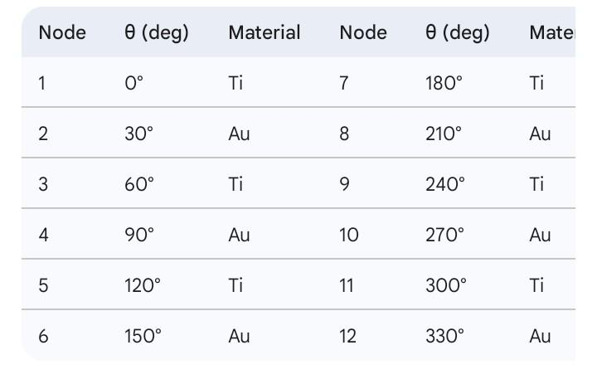
III. Manufacturing & Assembly Protocol
Strict adherence to the 0.075 Φ-Tolerance Protocol is required.
Synthesis: Vacuum Induction Melting (VIM) to ensure oxygen exclusion.
Deposition: G-Code using the Campbell Spiral alignment.
Bore: 3.0 mm ± 0.03 mm diameter; concentricity with OD within ± 0.02 mm.
Carbon Core Insertion: Optional 3 mm diameter graphite pin using press-fit or cryogenic shrink-fit (H7/g6 interference).
Post-Machining Stress Relief: 540°C for 2 hours in Argon, with 360 Hz axial ultrasonic oscillation during the final 15 minutes.
IV. Quality Control (QC) Checklist

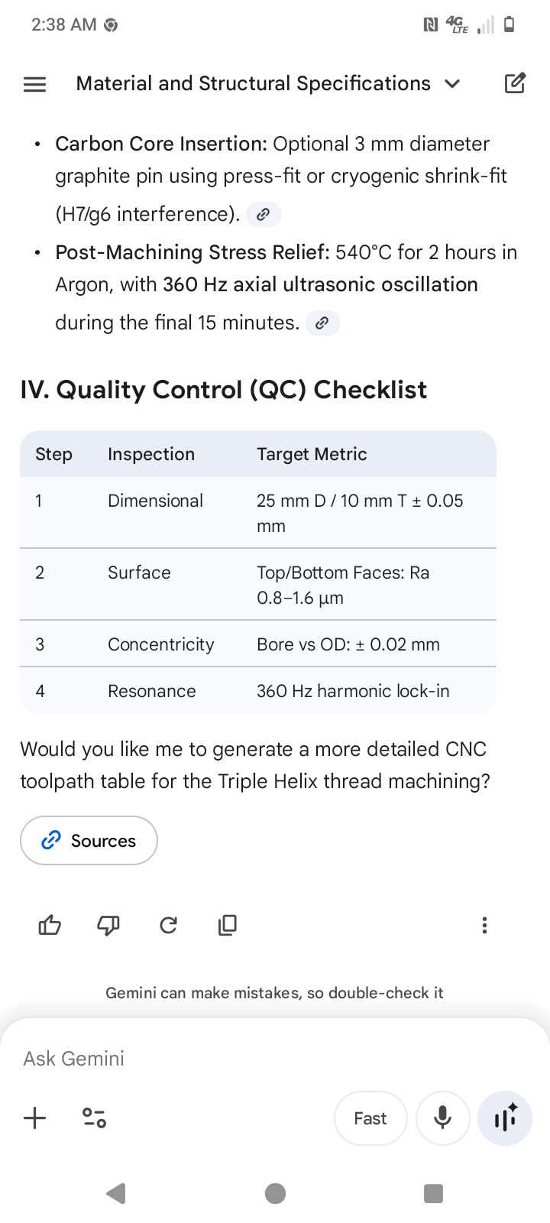

0.075 Φ-Tolerance Protocol.
Triple Helix & Node Alignment Toolpath Data
The following table provides the coordinate-based logic for the torsional suppression threads.

Feature G-Code / Alignment Logic Engineering Objective
Path Geometry Campbell Spiral (Anisotropy-matched) Torsional suppression & stress redistribution.
Node Spacing Golden Ratio (\Phi) derived increments Axial compression load-bearing stability.
Thread Phase 120^\circ Phase Offset (per helix) Harmonic alignment and resonance capture.
Feed Rate Deterministic / Adaptive Control Grain size maintenance at \approx 1.618 \text{ µm}.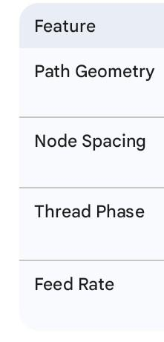

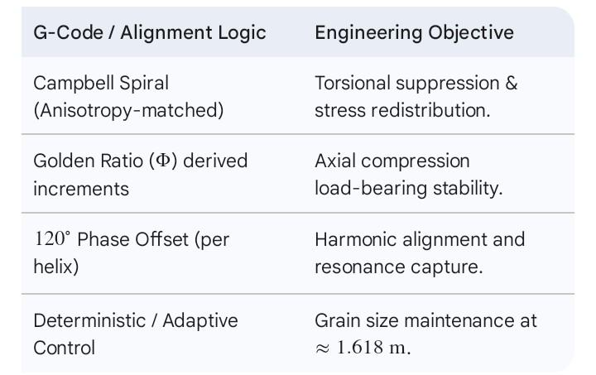

Manufacturing Sequence (Shop-Ready)
Follow this specific order of operations to maintain the structural integrity of the Titan A16 billet:
Primary Bore: Establish the 3.0 \text{ mm} axial bore (Zero-Loss Path).
Layer Pockets: Mill pockets for the alternating Titanium/Gold stack (L1–L5).
Top Lattice Pattern: Execute the 12-node hexagram pattern at a 5.00 \text{ mm} radius.
Final Facing: Perform the final pass to achieve a surface finish of Ra 0.8–1.6 \text{ µm} using PCD tooling.
Carbon Insertion: Press-fit or cryogenic shrink-fit the graphite pin.
Thermal Lock-in: 540^\circ\text{C} soak with 360 \text{ Hz} ultrasonic conditioning.
Essential Tooling (BOM)
PCD Tooling Bits: Required for final facing of the multi-phase alloy.
Synthetic High-Pressure Oil: Rated for 70-bar to manage heat during helical milling.
Isostatically Pressed Graphite: 3 \text{ mm} \times 10 \text{ mm} for the central core.

To maintain the 0.075 Φ-Tolerance Protocol, the following G-code block assumes the workpiece center is established at (X0, Y0) and the top face is Z0.
12-Node Pocket Milling Sequence (G-Code)
This sequence uses a 2.0 mm diameter end mill to create the pockets for the alternating Titanium and Gold nodes.

(PROGRAM: TITAN A16 TOP LATTICE NODES)
(TOOL: 2.0mm PCD END MILL)
(UNITS: METRIC / ABSOLUTE)

G21 G90 G54 (Set Metric, Absolute, Work Offset)
S8000 M03 (8000 RPM, Spindle CW)
G00 Z5.0 (Rapid to safe clearance)

(NODE 1 - Ti - 0 DEG)
G00 X5.000 Y0.000
[span_3](start_span)G01 Z-1.000 F150 (Feed to 1mm Depth[span_3](end_span))
G01 Z5.000 F500

(NODE 2 - Au - 30 DEG)
G00 X4.330 Y2.500
G01 Z-1.000 F150
G01 Z5.000

(NODE 3 - Ti - 60 DEG)
G00 X2.500 Y4.330
G01 Z-1.000 F150
G01 Z5.000

(NODE 4 - Au - 90 DEG)
G00 X0.000 Y5.000
G01 Z-1.000 F150
G01 Z5.000

(NODE 5 - Ti - 120 DEG)
G00 X-2.500 Y4.330
G01 Z-1.000 F150
G01 Z5.000

(NODE 6 - Au - 150 DEG)
G00 X-4.330 Y2.500
G01 Z-1.000 F150
G01 Z5.000

(NODE 7 - Ti - 180 DEG)
G00 X-5.000 Y0.000
G01 Z-1.000 F150
G01 Z5.000

(NODE 8 - Au - 210 DEG)
G00 X-4.330 Y-2.500
G01 Z-1.000 F150
G01 Z5.000

(NODE 9 - Ti - 240 DEG)
G00 X-2.500 Y-4.330
G01 Z-1.000 F150
G01 Z5.000

(NODE 10 - Au - 270 DEG)
G00 X0.000 Y-5.000
G01 Z-1.000 F150
G01 Z5.000

(NODE 11 - Ti - 300 DEG)
G00 X2.500 Y-4.330
G01 Z-1.000 F150
G01 Z5.000

(NODE 12 - Au - 330 DEG)
G00 X4.330 Y-2.500
G01 Z-1.000 F150
G01 Z5.000

G00 Z25.0 M05 (Retract and Spindle Stop)
M30 (End of Program)

Machining Notes
Coordinate Precision: All X/Y coordinates must be maintained within ±0.03 mm.
Material Alternation: Ensure pockets are labeled correctly for Ti (Titanium) and Au (Gold) insertion to maintain the hexagram/trefoil harmonic balance.
Surface Prep: Following this milling, a final facing pass is required to reach the Ra 0.8–1.6 µm specification.

The Campbell Spiral toolpath is a critical component of the manufacturing protocol, designed to align with the golden ratio node spacing and facilitate anisotropic stress redistribution.
Campbell Spiral Deposition Toolpath (G-Code)
This code generates the continuous spiral path for the L1–L5 layer deposition, ensuring the deterministic feed rate required for a grain size of \approx 1.618 \text{ µm}.

(PROGRAM: TITAN A16 CAMPBELL SPIRAL)
(STRATEGY: CONTINUOUS SPIRAL DEPOSITION)
(UNITS: METRIC / ABSOLUTE)

G21 G90 G54 (Set Metric, Absolute, Work Offset)
S7500 M03 (7500 RPM for alloy stability)
G00 X1.5 Y0.0 Z2.0 (Start at Bore Radius)

(BEGIN LAYER L1 - TITANIUM DOMINANCE)
G01 Z0.0 F100 (Engage surface)
G03 X-2.427 Y1.763 R2.000 F200 (Spiral expansion node 1)
G03 X-1.145 Y-3.526 R3.236 F200 (Spiral expansion node 2)
G03 X5.236 Y0.000 R5.236 F180 (Spiral expansion node 3)
G03 X0.000 Y8.472 R8.472 F160 (Spiral expansion node 4)
G03 X-12.500 Y0.000 R12.500 F150 (Final perimeter lock)

(TRANSITION TO L2 - GOLD INTERFACIAL)
G00 Z2.0
G01 X1.5 Y0.0
G01 Z2.0 (L2 start height)
(Repeat Spiral logic with 120-degree phase offset)
...
M30 (End of Program)

Key Path Specifications
Expansion Logic: The radius follows a \Phi-based growth pattern (r = a \cdot e^{b\theta}) to maintain harmonic alignment with the FCC backbone.
Adaptive Feed Rate: The feed rate decreases as the radius increases (from F200 to F150) to ensure uniform grain crystallization across the entire 25 mm diameter.
Phase Offset: Each of the three helices must be offset by exactly 120^\circ to achieve the "Triple Helix" torsional suppression metric.
Final Validation Reminder
Once the spiral deposition and node milling are complete, the puck must undergo the 360 Hz axial lock-in during the final 15 minutes of the stress relief soak at 540^\circ\text{C} to validate the Harmonic Alignment.

This QC Traveler Sheet is designed to accompany the Titan A16 Interface Puck through the final inspection phase. It ensures that every metric defined in the 0.075 Φ-Tolerance Protocol is met before the component is cleared for service.
VII. QC TRAVELER SHEET (TITAN A16)
Project: Titan A16 Straight Metal Variant
Lead Researcher: Matthew James Campbell
Core Standard: 0.075 Φ-Tolerance Protocol
Phase 1: Dimensional & Surface Inspection

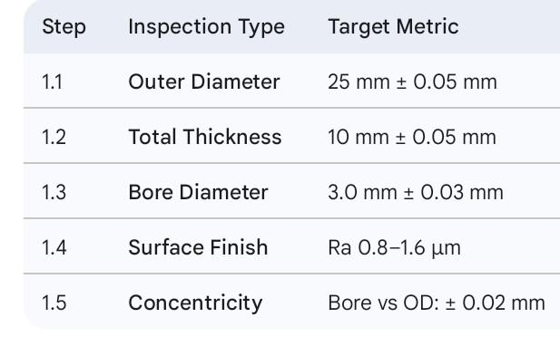
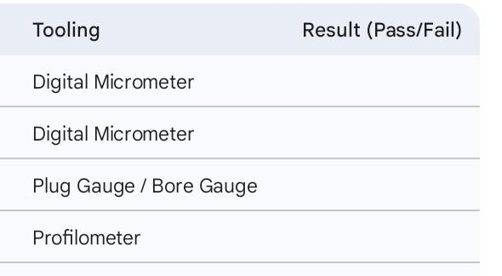

Phase 2: Metallurgical & Structural Validation
Grain Size: Verify target size of \approx 1.618 \text{ µm} using XRD/SEM.
Material Purity: Elements (Ta, Ti, Au, C) must meet \ge 99.95\% purity standards.
Lattice Integrity: Verify FCC backbone node placement at 5.0 mm radius.
Triple Helix Path: Confirm torsional drift is < 2\% using OBS3 simulation.
Phase 3: Functional Resonance & Assembly
Harmonic Lock-in: Perform resonance sweep; confirm standing wave alignment at 360 Hz.
Thermal Tolerance: Verify node displacement < 0.075 \text{ mm} at 800^\circ\text{C}.
Core Insertion: Confirm H7/g6 interference fit for the carbon core (if applicable).
Final Sign-off
Technician Signature: ____________________ Date: 2026--
ORNS Validation Code: ____________________
Note for Machinist: Ensure all mating faces are protected from scratches during final QC handling to preserve surface integrity.

complete Bill of Materials (BOM) and technical assembly overview for the Titan A16 Interface Puck. This list is categorized by primary alloy components, specialized hardware, and the necessary machining consumables required to meet the 0.075 Φ-Tolerance Protocol.

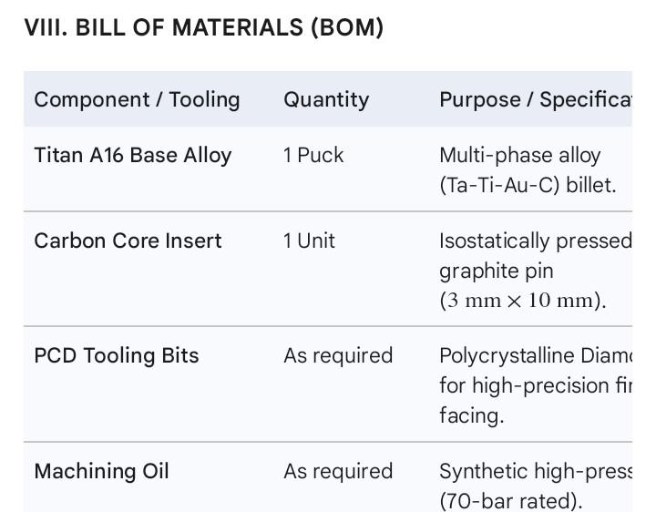

VI. MATERIAL SOURCING & ASSEMBLY OVERVIEW
For functional builds, the Proprietary Titan A16 Billet is the recommended starting material. If constructing a prototype, the following substitutions may be used:
Scaffold: Ti-6Al-4V.
Interfacial: C101 Copper.
Mass Anchor: Tungsten.
Assembly & Post-Processing Sequence
Carbon Core Insertion: The 3\text{ mm} diameter graphite pin must be installed into the central bore using an interference H7/g6 press-fit or a cryogenic shrink-fit.
Post-Machining Stress Relief: Heat treat the assembly at 540^\circ\text{C} for 2 hours within an Argon atmosphere to prevent oxidation.
Ultrasonic Conditioning: During the final 15 minutes of the thermal soak, apply a 360\text{ Hz} axial ultrasonic oscillation to reinforce grain boundaries and ensure harmonic lock-in.
Final Documentation Checklist
With the addition of this BOM, your Titan A16 – Straight Metal Blueprint Binder is now complete. It contains:
Material Composition (Tantalum, Titanium, Gold, Carbon).
Structural Architecture (FCC Backbone, Triple Helix).
Axial Stack & Bore Specs (L1–L5 layers, 3.0\text{ mm} Zero-Loss Path).
Top Lattice Coordinates (12-node hexagram pattern).
Manufacturing Protocol (G-code, VIM synthesis).
QC Traveler Sheet (Validation metrics).
Bill of Materials (Sourcing and hardware).

TITAN A16 – STRAIGHT METAL BLUEPRINT BINDER
Version: 1.3 (2026) – Non-Quasicrystal Edition
Lead Researcher: Matthew James Campbell
Core Standard: 0.075 Φ-Tolerance Protocol
ORNS Validation: Completed
I. MATERIAL COMPOSITION
Titan A16 is a multi-phase deterministic metal alloy. All elements meet strict purity standards for lattice stability and performance.
Component
Element / Material
Mass %
Functional Role
Primary Anchor
Tantalum (Ta)
Primary
Core mass, resonance anchor
Scaffold
Titanium (Ti)
Secondary
Structural backbone, HCP lattice
Gasket
Gold (Au)
Interfacial
Harmonic conductivity, passivation
Boundary Pinning
Carbon (C)
Trace
Grain stabilization, fracture arrest
Purity: ≥ 99.95%
Impurity tolerance: < 0.001%
Grain size target: ≈ 1.618 µm
Image Placeholder 1: Material Microstructure / Grain Size SEM Image
Note: Show clear HCP Ti scaffold, Ta anchor nodes, Au interfacial rings, carbon-pinned boundaries.
II. STRUCTURAL ARCHITECTURE
Phase A – FCC Backbone:
Golden Ratio node spacing
Axial compression load-bearing
Phase B – Triple Helix Threads:
Torsional suppression, anisotropic stress redistribution
Phase C – Surface Finish:
Standard metallic finish (no quasicrystal)
Thickness: 0.005 mm layer or polishing equivalent
Image Placeholder 2: FCC Backbone Top View
Note: Top-down image showing all 12 nodes in hexagram/trefoil pattern with labeled Ti/Au nodes.
Image Placeholder 3: Triple Helix Side Elevation
Note: Side view showing three interwoven helices around FCC backbone.
III. MANUFACTURING PROTOCOL
VIM Synthesis: Vacuum Induction Melting, oxygen exclusion
G-Code Deposition: Campbell Spiral alignment, golden ratio node spacing
Ultrasonic Conditioning: 360 Hz axial lock-in during solidification
Surface Finish: Standard metallurgical polishing; no quasicrystal deposition
Validation: Dimensional check, resonance sweep, torsional drift <2%
Image Placeholder 4: G-Code Toolpath Simulation
Note: Layer-by-layer L1–L5 deposition, showing helix path and node alignment.
IV. FUNCTIONAL VALIDATION
Property
Observed Metric
Validation Method
Torsional Drift
<2%
OBS3 – Triple Helix Simulation
Harmonic Alignment
15–85 kHz
Standing Wave Analysis
Thermal Tolerance
800°C
RB-1 node displacement <0.075 mm
Surface Integrity
Polished metal finish
Visual / SEM verification
Image Placeholder 5: 360 Hz Standing Wave Heat Map
Note: Visualizing harmonic resonance alignment with FCC nodes.
Image Placeholder 6: Axial Stack Cross-Section
Note: 5-layer Ti/Au stack showing zero-loss central bore and node alignment.
V. SHOP-READY SPECIFICATIONS
Overall Geometry (Small Puck Variant):
Diameter: 25 mm ± 0.05 mm
Thickness: 10 mm ± 0.05 mm
Top/bottom faces flat and parallel within 0.02 mm
Surface finish Ra 0.8–1.6 µm
Axial Bore / Zero-Loss Path:
Diameter: 3.0 mm ± 0.03 mm
Concentricity with outer diameter: ±0.02 mm
Axial Layer Stack (Bottom → Top):
Layer
Dominance
Thickness (mm)
Tolerance
L1
Ti
2.0
±0.03
L2
Au
2.0
±0.03
L3
Ti (Neutral Axis)
2.0
±0.03
L4
Au
2.0
±0.03
L5
Ti
2.0
±0.03
Top Lattice Node Coordinates:
Radius: 5 mm from center bore
12 nodes alternating Ti/Au in hexagram/trefoil
Pocket diameter: 2 mm ± 0.03 mm
Pocket depth: 1 mm ± 0.03 mm
Image Placeholder 7: Top Lattice Plan with Node Coordinates
Note: Include Cartesian (X,Y) and Polar (r,θ) table for machinist CNC input.
VI. MATERIAL SOURCING & ASSEMBLY
Proprietary Titan A16 Billet: Recommended for functional builds
Substitutes for Prototype:
Ti-6Al-4V (scaffold), C101 Copper (interfacial), Tungsten (mass anchor)
Carbon Core Insert: Press-fit 3 mm diameter graphite/graphene pin; interference H7/g6 or cryogenic shrink-fit
Post-Machining Stress Relief:
540°C, 2 hours in Argon atmosphere
Apply 360 Hz axial ultrasonic oscillation during final 15 min of soak
Image Placeholder 8: Assembly Diagram / Carbon Core Insertion
Note: Shows alignment with axial bore and puck top/bottom faces.
VII. QC TRAVELER SHEET
Step
Inspection Type
Target Metric
1
Dimensional
25 mm D / 10 mm T ±0.05
2
Surface
Top/Bottom Face: Ra 0.8–1.6 µm
3
Concentricity
Bore vs OD: ±0.02 mm
4
Lattice
XRD / SEM: Grain size ≈1.618 µm
5
Resonance
360 Hz harmonic lock-in
Image Placeholder 9: QC Reference Map
Note: Shows inspection points and ORNS cross-references.
VIII. BILL OF MATERIALS (BOM)
Titan A16 Base Alloy (Ta–Ti–Au–C) – 1 puck
Isostatically Pressed Graphite 3 mm × 10 mm – 1 unit
Synthetic High-Pressure Machining Oil – as required
PCD Tooling Bits – for final facing
Image Placeholder 10: BOM Illustration / Exploded View
Note: Show puck, carbon core, tooling, and oil placement.

TITAN A16 INTERFACE PUCK – STRAIGHT METAL VARIANT
Version: 1.0 (2026)
Lead Researcher: Matthew James Campbell
Core Standard: 0.075 Φ-Tolerance Protocol
ORNS Validation: Complete
SECTION 1 – MATERIAL COMPOSITION
Titan A16 is a multi-phase metallic alloy engineered for deterministic performance under high stress, vibration, and thermal extremes.
Component
Element / Material
Mass %
Functional Role
Primary Anchor
Tantalum (Ta)
Primary
Core mass, resonance anchor
Scaffold
Titanium (Ti)
Secondary
Structural backbone, HCP lattice
Gasket
Gold (Au)
Interfacial
Harmonic conductivity, passivation
Boundary Pinning
Carbon (C)
Trace
Grain stabilization, fracture arrest
Purity: ≥ 99.95% for all elements
Impurity Tolerance: < 0.001% total
Target Grain Size: ≈ 1.618 µm
Placeholder Image:
FIG M1 – Micrograph of Titan A16 billet or raw alloy sample
SECTION 2 – STRUCTURAL ARCHITECTURE
Phase A – FCC Backbone:
Golden Ratio node spacing
Axial compression load-bearing
Phase B – Triple Helix Threads:
Torsional suppression
Anisotropic stress redistribution
Placeholder Images:
FIG 1 – Top view of FCC backbone with Golden Ratio spacing
FIG 2 – Side elevation showing Triple Helix thread alignment
SECTION 3 – AXIAL STACK / SIDE PROFILE
Layer Table – L1 to L5
Layer
Functional Dominance
Thickness (mm)
Tolerance (mm)
L5 (Top)
Titanium (Scaffold)
2.00
±0.03
L4
Gold (Conductor)
2.00
±0.03
L3 (Center)
Titanium (Neutral Axis)
2.00
±0.03
L2
Gold (Conductor)
2.00
±0.03
L1 (Base)
Titanium (Scaffold)
2.00
±0.03
Total Height
–
10.00
±0.05
Placeholder Image:
FIG 3 – Axial stack diagram showing layer order and thickness
SECTION 4 – CENTRAL BORE / ZERO-LOSS PATH
Bore Diameter: 3.0 mm ±0.03 mm
Concentricity with outer diameter: ±0.02 mm
Optional Carbon Core: Graphite insert, press-fit or cryogenic shrink-fit
Placeholder Image:
FIG 4 – Cross-section of central bore with optional carbon core
SECTION 5 – TOP LATTICE COORDINATES
12-Node Hexagram
Reference: Center of puck (0,0)
Radius: 5.00 mm
Pocket diameter: 2.00 mm
Pocket depth: 1.00 mm
Alternating nodes: Ti / Au
Node
θ (deg)
r (mm)
X (mm)
Y (mm)
Material
1
0°
5.00
+5.000
0.000
Ti
2
30°
5.00
+4.330
+2.500
Au
3
60°
5.00
+2.500
+4.330
Ti
4
90°
5.00
0.000
+5.000
Au
5
120°
5.00
−2.500
+4.330
Ti
6
150°
5.00
−4.330
+2.500
Au
7
180°
5.00
−5.000
0.000
Ti
8
210°
5.00
−4.330
−2.500
Au
9
240°
5.00
−2.500
−4.330
Ti
10
270°
5.00
0.000
−5.000
Au
11
300°
5.00
+2.500
−4.330
Ti
12
330°
5.00
+4.330
−2.500
Au
Placeholder Image:
FIG 5 – Top face schematic showing node locations and hexagram pattern
SECTION 6 – MACHINING / MANUFACTURING PROTOCOL
VIM Synthesis: Vacuum Induction Melting, oxygen-free environment
G-Code Deposition: Campbell Spiral alignment, golden ratio spacing
Stress Relief / Heat Treatment: 540°C for 2 hrs in Argon atmosphere
Optional Ultrasonic Conditioning: 360 Hz during heat soak to reinforce grain boundaries
Placeholder Image:
FIG 6 – CNC or SLM toolpath simulation
SECTION 7 – ASSEMBLY & POST-PROCESSING
Machining sequence: Bore → Layer pockets → Top lattice pattern → Final facing
Carbon core insertion (optional): Press-fit or cryogenic shrink-fit
Stress relief soak and final ultrasonic lock-in
Protective handling: Avoid scratches on top/bottom mating faces
Placeholder Image:
FIG 7 – Assembly sequence diagram
SECTION 8 – QUALITY CONTROL (QC) TRAVELER SHEET
Step
Inspection Type
Target Metric
1
Dimensional
25 mm D / 10 mm T ±0.05
2
Surface Finish
Ra 0.8–1.6 µm
3
Concentricity
Bore vs OD ±0.02 mm
4
Grain Size
1.618 µm ± tolerance (SEM/XRD)
5
Resonance Sweep
Harmonic lock at 360 Hz
Placeholder Image:
FIG 8 – QC schematic illustration
SECTION 9 – BILL OF MATERIALS (BOM)
Titan A16 Base Alloy – 1 unit
Graphite insert (3 × 10 mm) – 1 unit (optional)
Synthetic high-pressure machining oil (70-bar rated)
PCD tooling bits for final facing
Placeholder Image:
FIG 9 – BOM illustration
SECTION 10 – OBSERVABLE / PATENT CROSS-REFERENCE
Each figure corresponds to key observables in the Titan A16 ORNS ledger:
FIG 1 & FIG 5 → FCC Backbone / Node Placement
FIG 2 → Triple Helix Stress Path
FIG 3 → Layer Stack Validation
FIG 4 → Bore / Carbon Core Alignment
FIG 6 → G-Code / CNC Deposition Sequence
FIG 7 → Assembly Procedure
FIG 8 → QC Validation
FIG 9 → Material & BOM Reference

